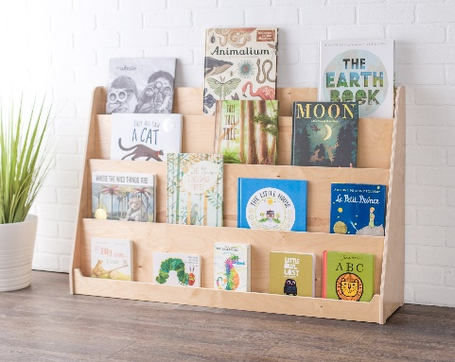
^{17th} December 2024

Dear parents/carers,

As you are aware, reading is a huge priority here at Anton and we are continuously looking at ways to promote a love of reading. We want to ensure that all children have access to a wide range of books. With this in mind, we will be introducing a ‘books with legs’ initiative in the new year. This initiative aims to reuse unwanted books, which children can then take home, keep or swap as they please. There will be a shelving unit placed in the office area, so that children and parents can have access to these books at their convenience.

If you have any old (but still readable condition!) books that your children no longer need/ read, we would love to take them off your hands and give them a new home. If you are able to support us, please donate your unwanted books via the school office, or your child can give them directly to their class teacher.

We are also pleased to announce that our library is now open and stocked full of brilliant new books. Your child will have the opportunity to visit the library every 2 weeks and will be able to take out two books at a time. Your child’s library day will be confirmed in your parent information handout, at the start of Spring 1. Please can we ask that these books are well looked after and returned on a fortnightly basis. If a book has been lost or damaged, please inform your child’s class teacher as soon as possible.

Thank you for your continued support,
Mrs Dockree

