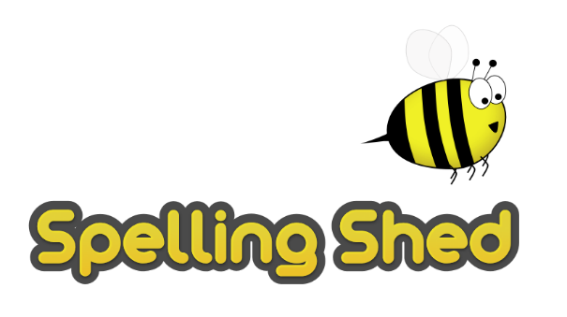
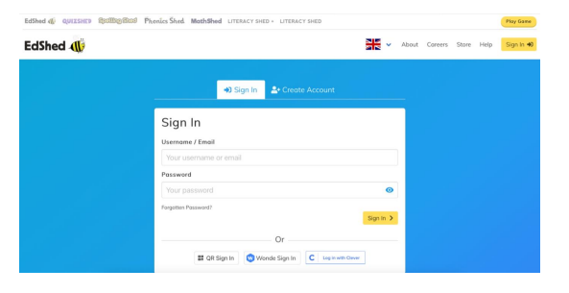
Supporting spellings at home
At Anton, we believe that teaching the children to become confident spellers is an important life skill. Each week, the children have a different set of words – linking to a spelling rule or statutory word list – that they will practice during three discrete spelling lessons. They will then be assessed on these words on a Friday through a dictation. These words can be found on the bottom on the half-termly homework and will also be uploaded to spelling shed each week. As part of their half-termly homework, we do ask that the children learn their spellings each week. We understand that it can be difficult to find the time during the week, however little and often is often the best strategy e.g. while making dinner, walking to school, while the bath is running etc…

To support you with this, we have created a simple guide on how to use spelling shed and attached some short (and hopefully fun) activity ideas to support the children learning their spellings at home.

For any further information, please do not hesitate to get in contact with your child’s class teacher.

Spelling shed is a fun and interactive website where children can practice their weekly spellings. All children have their own logins and will receive weekly assignments (games to play) that have been set by their class teacher and are linked to their weekly spellings.

Visit: https://www.edshed.com/en-gb/login or download the Spelling Shed App.

Login using your child’s username and password, which should be stuck on the inside of their yellow reading diary.

.

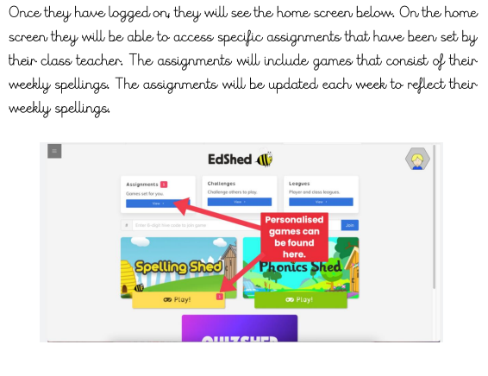
Once they have logged on, the screen will look like this. On the home screen, they will be able to access specific assignments that have been set by their class teacher. The assignments will include games, which link to their weekly spellings. The assignments will be updated each week to reflect their weekly spellings. There may also be a ‘pink 1’ highlighted next to challenges. This indicates an additional challenge, which may be set across year groups or the whole school.

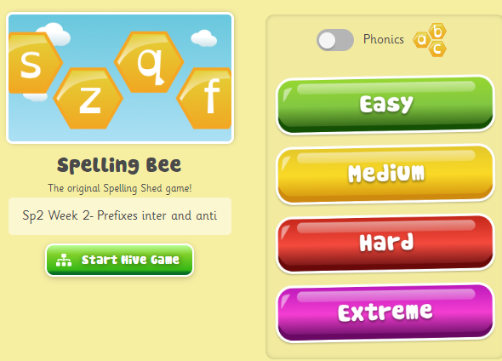
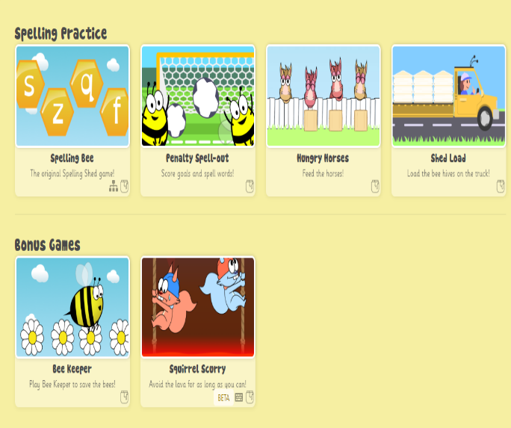
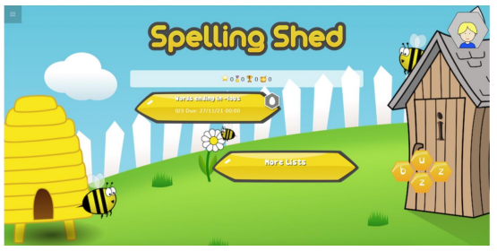
When you have clicked on your child’s assignment for the week, they will be given the option to play different games. They will also be given the option to select the level of difficulty for each game from easy to extreme! They will have the opportunity to earn points and buy clothing/accessories for their avatar.



