Dear Parent/Carer,
On 2nd November 2026 we will be moving to the Autumn-Winter, which runs until the Easter Break.
What you need to do
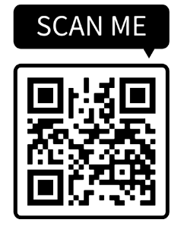
Please review the attached medical diet menu for your child and complete the online Parent Confirmation Form using the link or QR code provided.

If we do not receive the completed online form or hear from you, we will progress with the menu.

If you have any questions, please contact the Hampshire Medical Diet Team at
hampshiremedicaldiets@compass-group.co.uk
Thank you for your continued support in helping us keep children with medical diets safe and well supported.

Kind regards,
Hampshire Medical Diet Team

